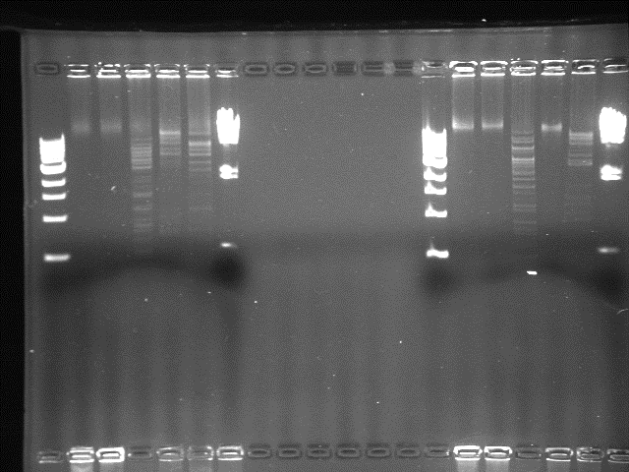

Uncut DNA

/Hind III

HindIII

ClaI

BamHI

1 kb marker

EcoRI

3 kb

1 kb

10 kb

23 kb

4.3 kb

2 kb