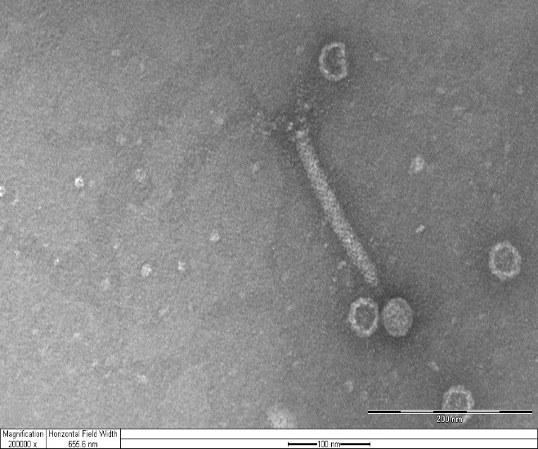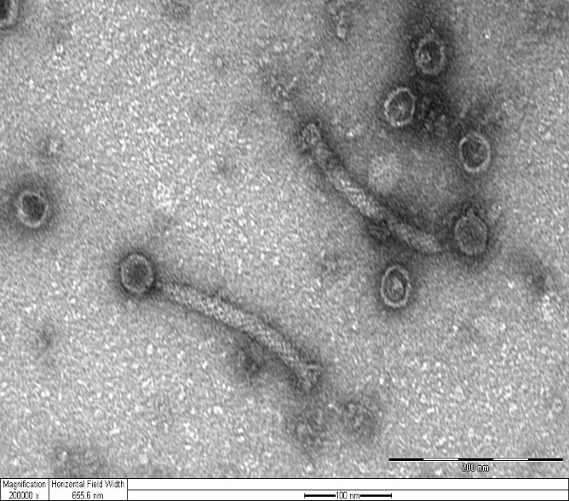

Table: Electron Microscopy measurement
 | HEAD | NECK | TAIL
1 | L: 52.6nm  W: 39.7nm | 11.5nm | 210.3nm
2 | L:53.8nm  W:38.5nm | 10.3nm | 200nm
3 | L:57nm  W:51.3nm | 10.7nm | 238.5nm
AVERGE | L:54.7nm  W:43.6nm | 10.8nm | 216.1nm

