2012
JMU PHAGE Archiving Report:

Phage Designator: | Straubster
Your name: | Joseph Charles Straub
Instructor: | Dr Ronald W. Raab
Note: Please fill in Phage designator in header on every page of this report.
General Info:
Phage Name: | Straubster
Collected By: | Joseph Charles Straub
Host Name:
Date Discovered: | August 19th, 2012
Sample Type  (e.g., soil, lake, etc.): | Soil
Depth: | Approximately 6 inches under ground
Approximate Temp: | 75°F
General Location: | Huntington, L.I., N.Y.
GPS Reading: | 40°51’54”N, 73°25’0”W
Sample Site Descriptors: | Wet, Humid, Under Grass
OPTIONAL:
pH of Soil:
Date of Enrichment protocol (if performed)
If multiple phages were isolated from one enrichment, please list phage designators of other phages isolated

Purification Information:
Plaque Morphology (size(mm)/appearance(clear-turbid-haloed)/incubation time(h)/incubation temp(°C): | 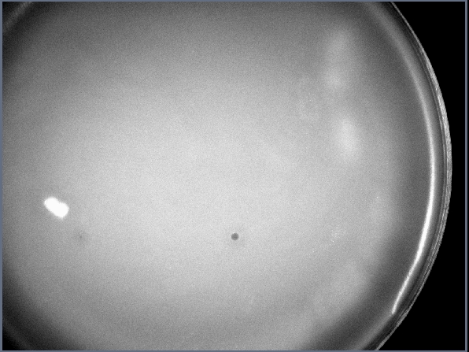
Single plaque purification and titer dates:
ROUND 1: | 9/17/12 Single plaque purification
ROUND 2: | 9/24/12 Single plaque purification
ROUND 3: | 9/26/12 Single plaque purification
ROUND 4: | 10/1/12 Single plaque purification
ROUND 5: | 10/17/12 Calculated Titer

Final lysate information:
Final lysate DATE: | 10/11/12
Titer pfu/mL: | 4.6 x 10¹² Plaques/mL
Volume sent μL (final) : | 10ml
Notes:

DNA Sample Information
DNA prep DATE: | 10/15/12
[DNA] μg/mL: | .7854 ug/mL
Volume sent μL (final) :

Plaque Picture

File Name: | Joe Straub 10.17.12.jpg / JS 9-24.jpg
Date: | 10/17/12 / 9/24/12

Electron Microscopy

File Name: | JCS-Straubster-1.tif / JCS-Straubster-2.tif
Date: | 11/20/12 / 11/20/12
Stain Used:
Titer: | 4.6 x 1012 Plaques/mL
Capsid Diameter: | 75 nm
Type of Tail: | contractile tail
Tail Length: | 30nm

Restriction Digest
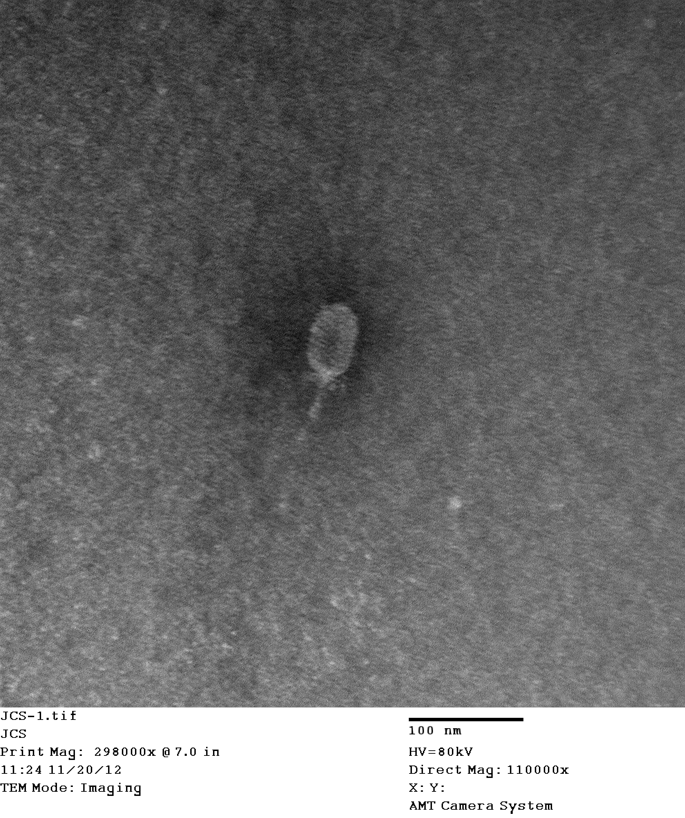
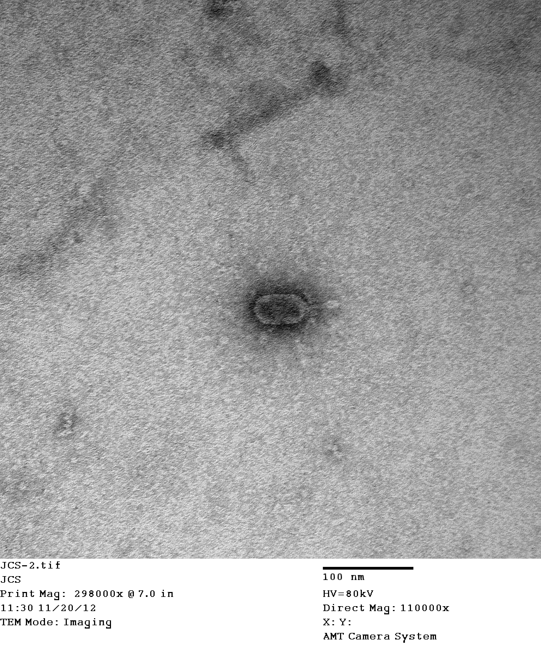
File Name: | See Blackboard
μg DNA per reaction: | .25ug/rxn for Bam HI, Eco RI, and HindIII.  .20ug/rxn for Bgl II
% Agarose:
Lane designations: | Lane contents:
Bam HI | Lane 1-11/5/12-bands present
Eco RI | Lane 1-11/5/12-bands present
HindIII | Lane 1-11/5/12-bands present
Bgl II | Lane 1-11/26/12-bands present

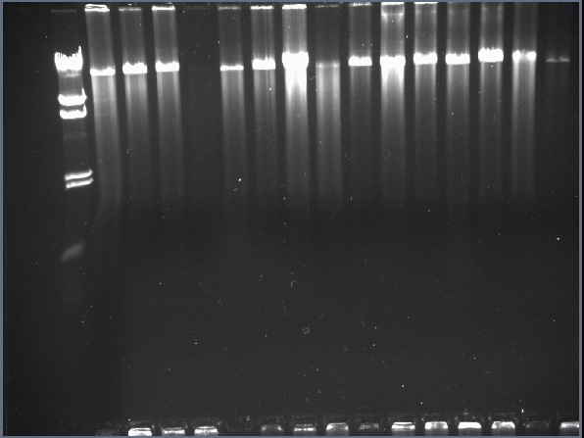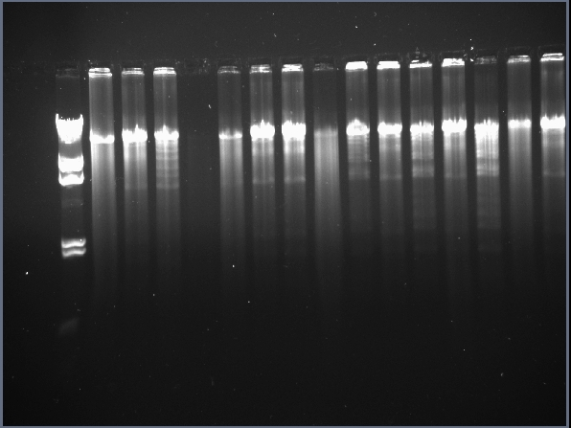
BamHI Lane 1 (+) EcoRI Lane 1 (+)
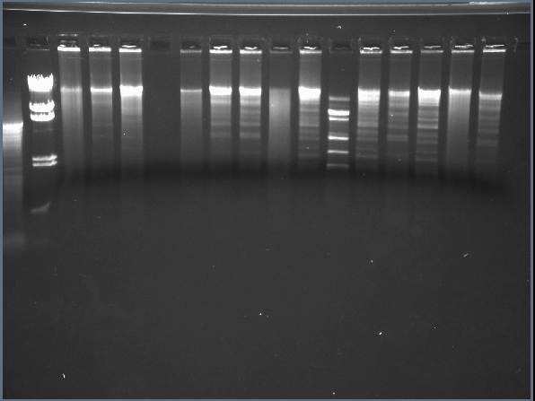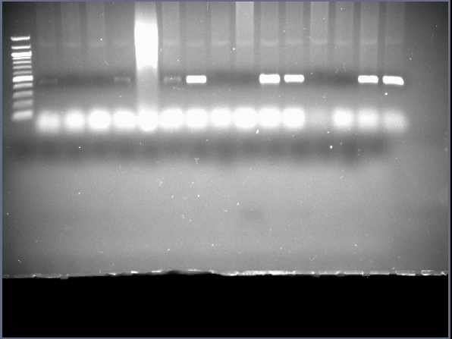
HinDIII Lane 1 (+) PCR Primer Set 1 Lane 1 (+) 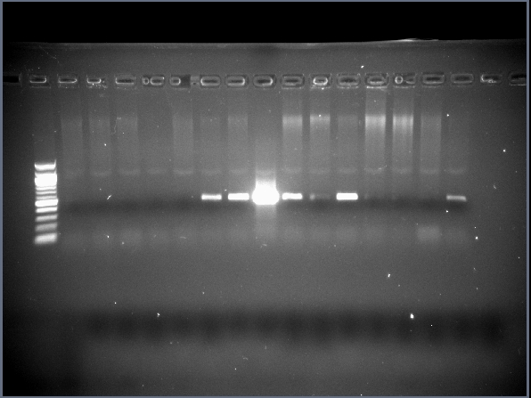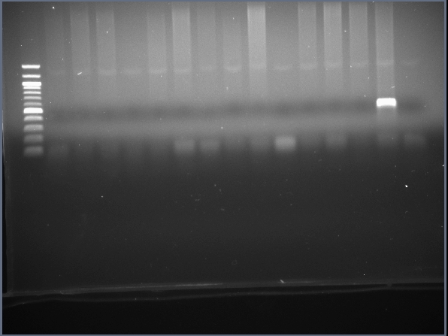
PCR Primer Set 2 Lane 1 (-) PCR Primer Set 3 Lane 1 (-)
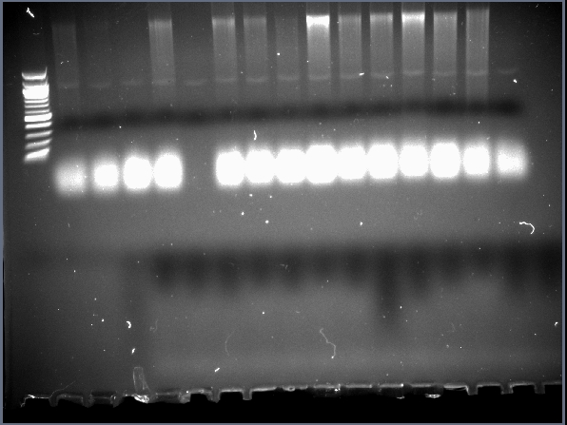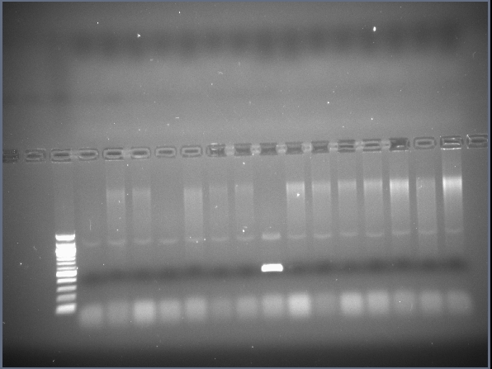
PCR Primer Set 4 Lane 1 (-) PCR Primer Set 5 Lane 1 (-)
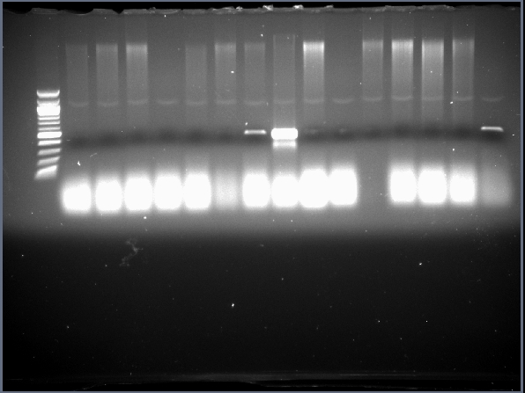
PCR Primer Set 6 Lane 1 (-)

