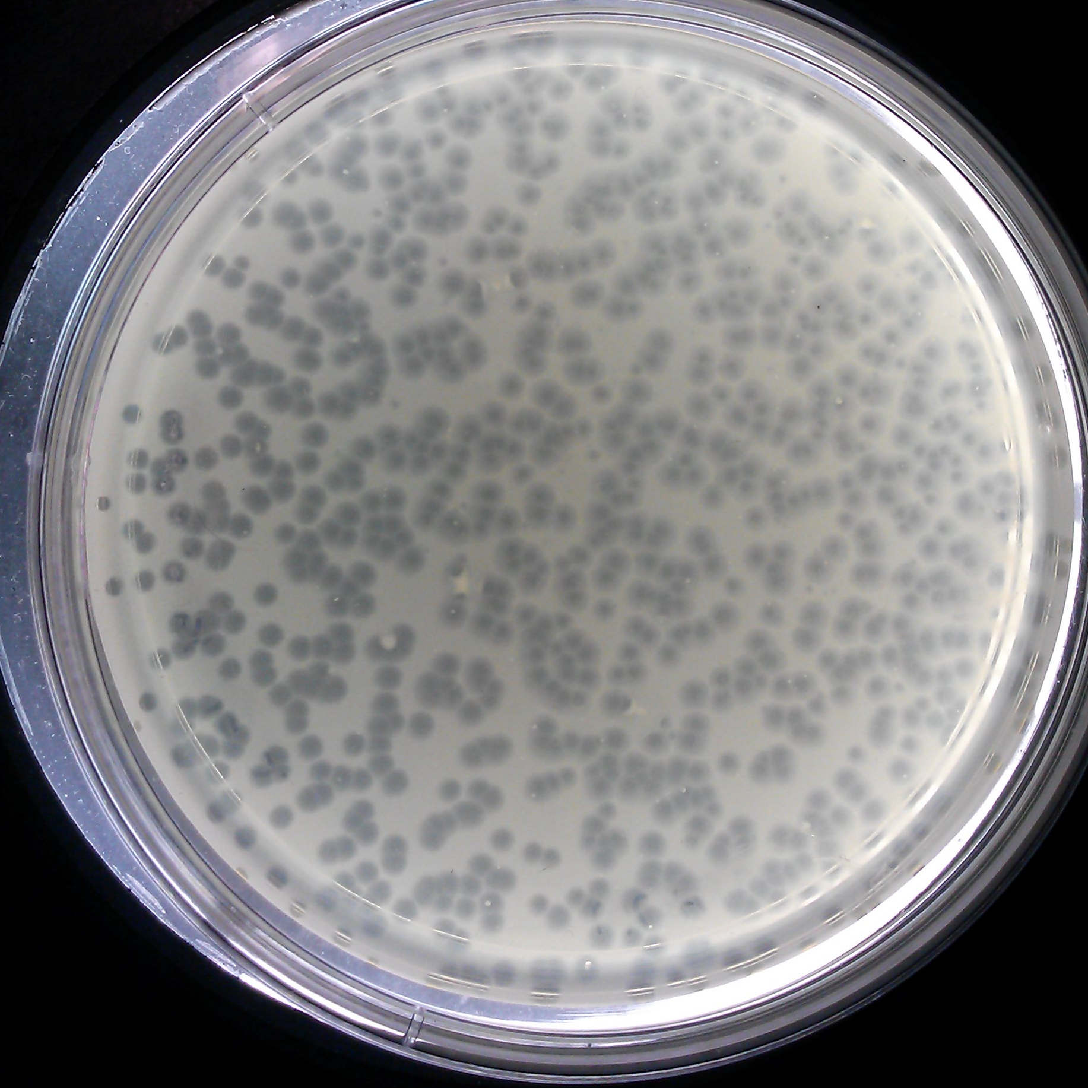

Dayo’s plaques on a plate. After the infection, Dayo’s plaques estimated a diameter of 3mm.

